Télécom Paris

Multimedia Networking

**Convolutional Neural Networks**

**based on VGG Architecture**

Contents

1. Introduction 2

2. Database 2

3. Model 2

4. Training 2

5. Results 2

6. Test 4

7. Comparison with TSP 4

8. Conclusion 4

# Introduction

In this work we have learn the study the VGG architecture and train CNN model for the classification of CIFAR-10 database based on VGG architcture.we explore the effect of the convolutional network depth on its accuracy on CIFAR-10. Our main contribution is a thorough adding droupout and batch normalization layers of networks of increase the stabiltiy of an architecture with very small (3x3) convolution filters, which shows that a significant improvement with accuracy.

# Database

The CIFAR-10 is consist of 60,000 32×32 pixel color images of objects from 10 classes, such as frogs, birds, cats, ships, etc. The class labels and their standard associated integer values are as follows. (0: airplane,1:automobile,2: bird,3: cat,4: deer,5: dog,6: frog,7: horse,8: ship,9: truck).These are very small images, much smaller than a typical photograph, and the dataset was intended for computer vision research.

CIFAR-10 is a well-understood dataset and widely used for benchmarking computer vision algorithms in the field of machine learning. We have divided the dataset into two categories; 50,000 images in the training dataset and 10,000 in the test dataset and these images are indeed square with 32×32 pixels and color, with three channels.

# Model

VGG-19 is a trained Convolutional Neural Network, from Visual Geometry Group, University of Oxford. The number 19 stands for the number of layers with trainable weights. 16 Convolutional layers and 3 Fully Connected layers.

The filter size used for all the convolutional layer is 3 by 3. The architecture of the network is as following:

The VGG-19 was initially designed to classify the ImageNet database with 1000 classes. For our application we should adapt this architecture to the dataset that we have. So we had to change the output to 10 instead of 1000 in the predefined VGG, and also we lower the complicity of the network so we can train it with the CIFAR-10 database.

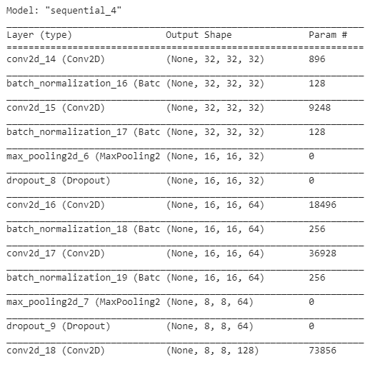

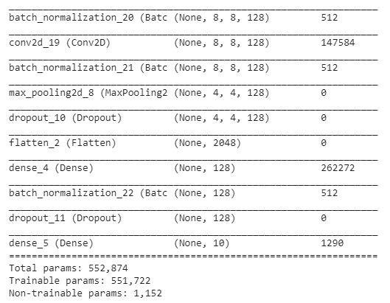

In our model we kipped the VGG base architecture, the modifications we made are:

* Add dropout layer to avoid after each bloc of convolutional layers and fully connected layers to avoid overfitting.
* Add batch normalization. This layer used to increase the stability of the network by normalizing the output of the previous layer to the range of the 0 to 1.
* Data augmentation: to improve our dataset and increase the size we are adding the function ImageDataGenerator from Keras.

# Training

The model was trained using batch normalization technique to improve the generalization of model. We applied rotation and horizontal flip to images batch by batch and input those images to our network.For the optimizer, ADAM technique is used with parameters:. In order to save the current weight during training, we create check point in every 10 epoch and stored trained model in Google Drive. The table shows training parameter.

|  |  |
| --- | --- |
| Parameters | Value |
| Batch Size | 64 |
| Number of steps | 781 |
| Epochs | 400 |
| Check point | Per 10 epochs |
| Learning rate | 10e-3 |
| Momentum | 0.9 |

# Results

The figure 1,2 plot the loss and accuracy as the function of epochs, the accuracy increase significantly in the first 100 epochs. Epoch 100 - 400 shows a gradually increasing in accuracy.

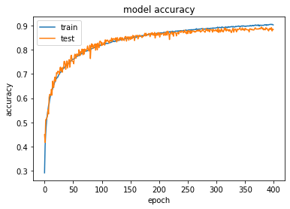

Figure 1: Model accuracy

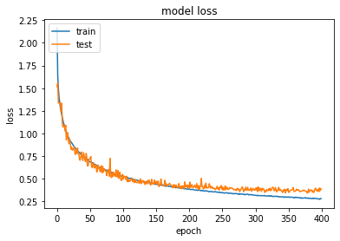

Figure 2 Model's loss

The 10x10 confusion matrix is shown in figure 3. As we can see in the figure 3, with 973 frog images are classified as frogs, the model have the highest accuracy on frog images. In the other hand only 694 over 1000 cat images are labeled as a cat, cats are most incorrectly labels as dog with 116 cases. The accuracy per class are show in figure 4.

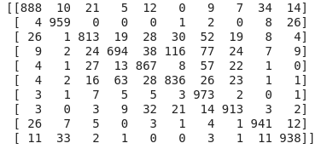

Figure 3 Confusion matrix

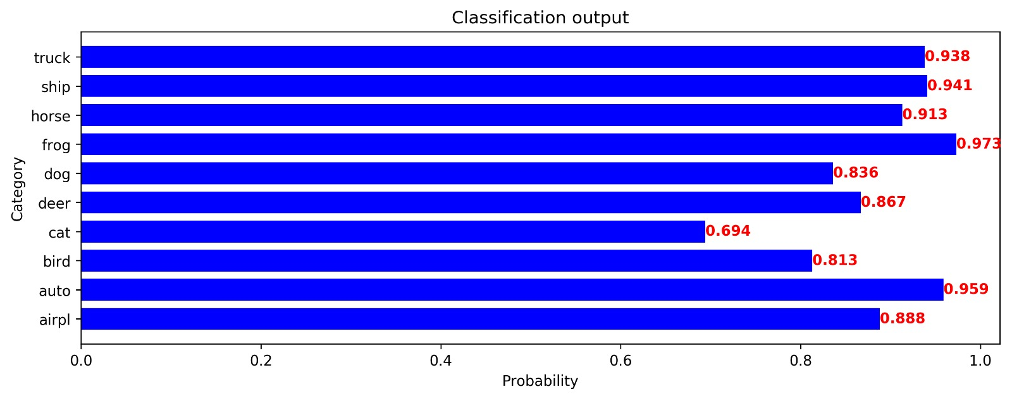

Figure 4 Accuracy per class

# Test

After training the model. We will show here some tests that we have performed over some samples of each category that we have presented to our trained network.

In the following figure we are presenting the used image and the probabilities got in the output layer of the network.

* Airplane

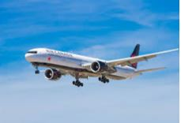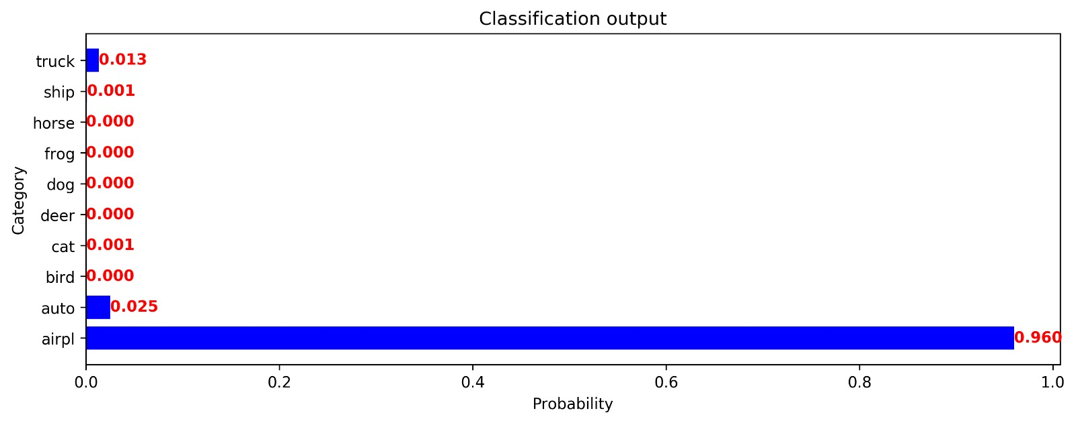

* Automobile

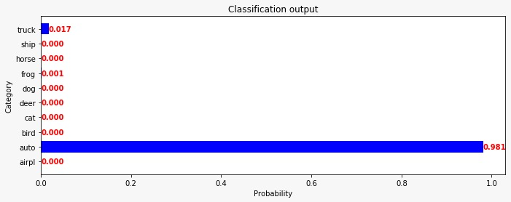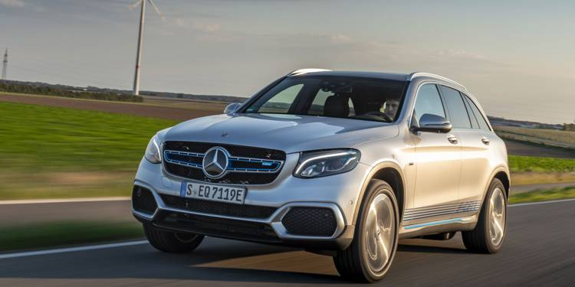

* Bird

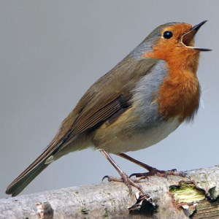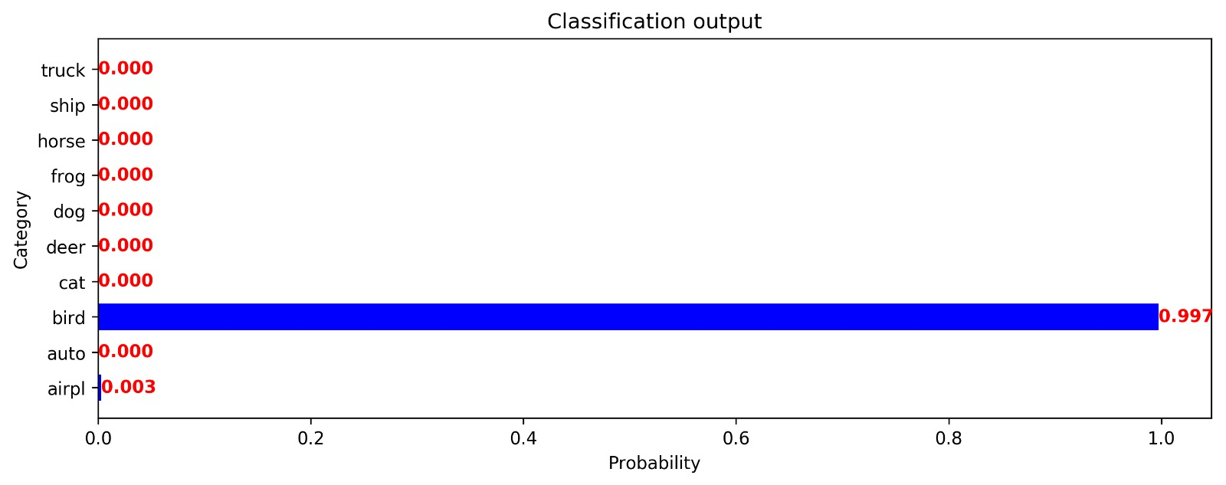

* Cat

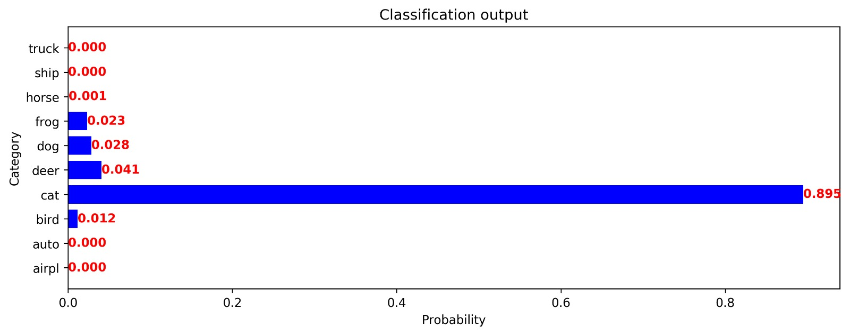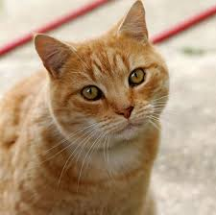

* Deer

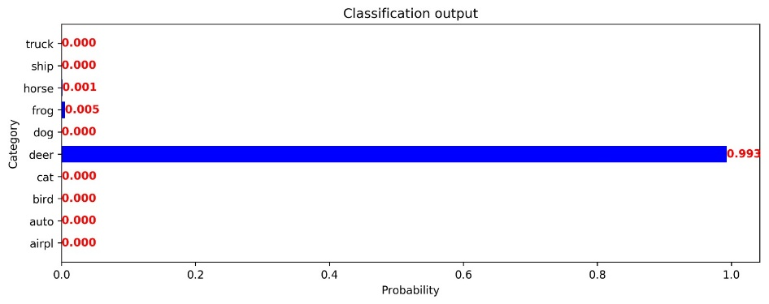

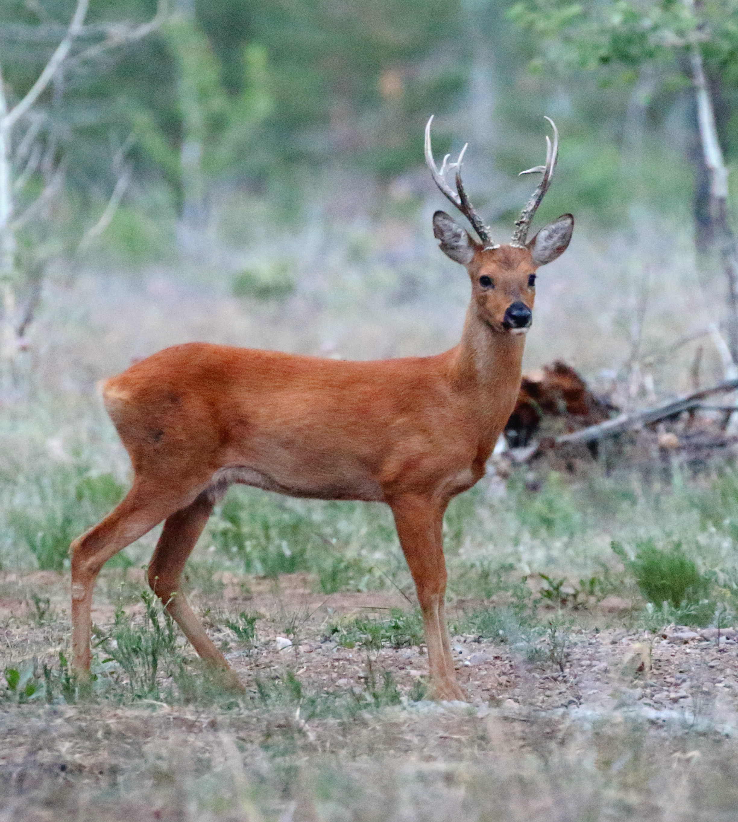

* Dog

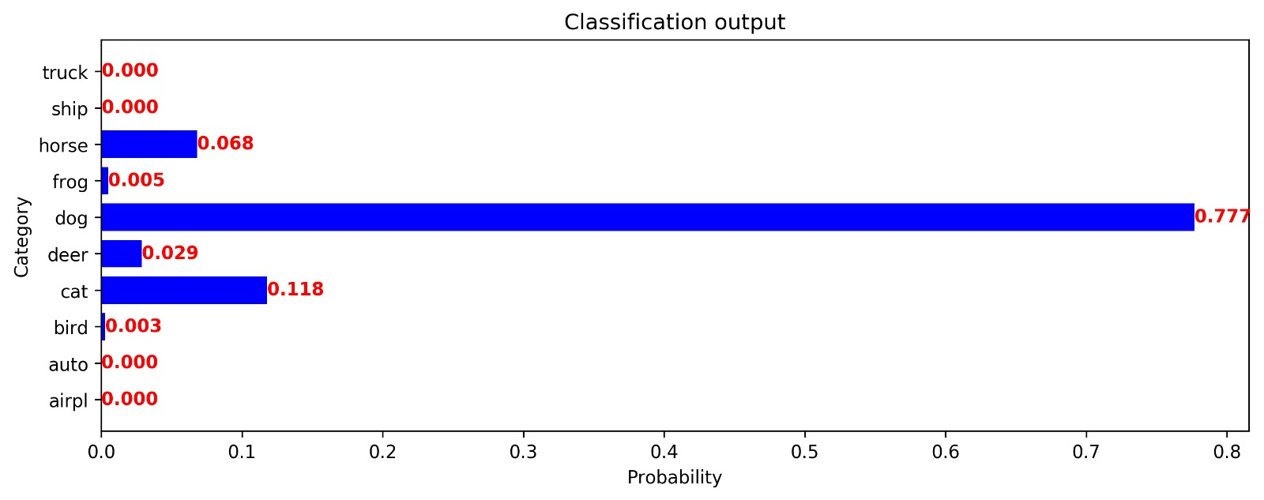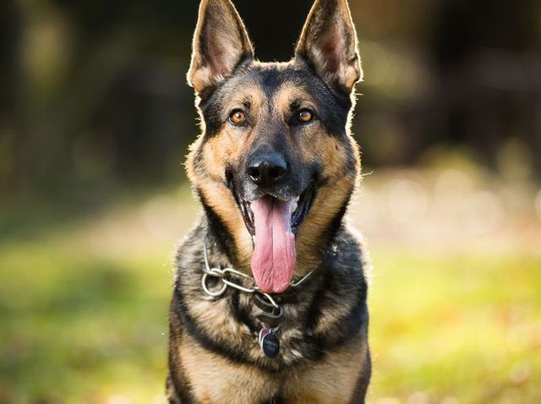

* Frog

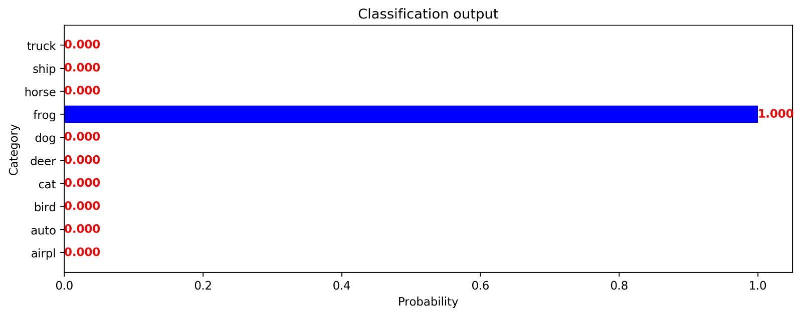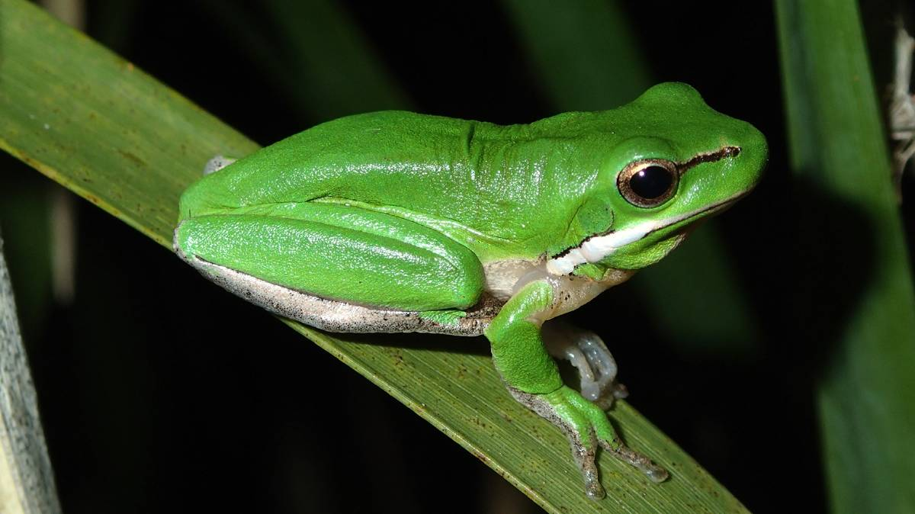

* Horse

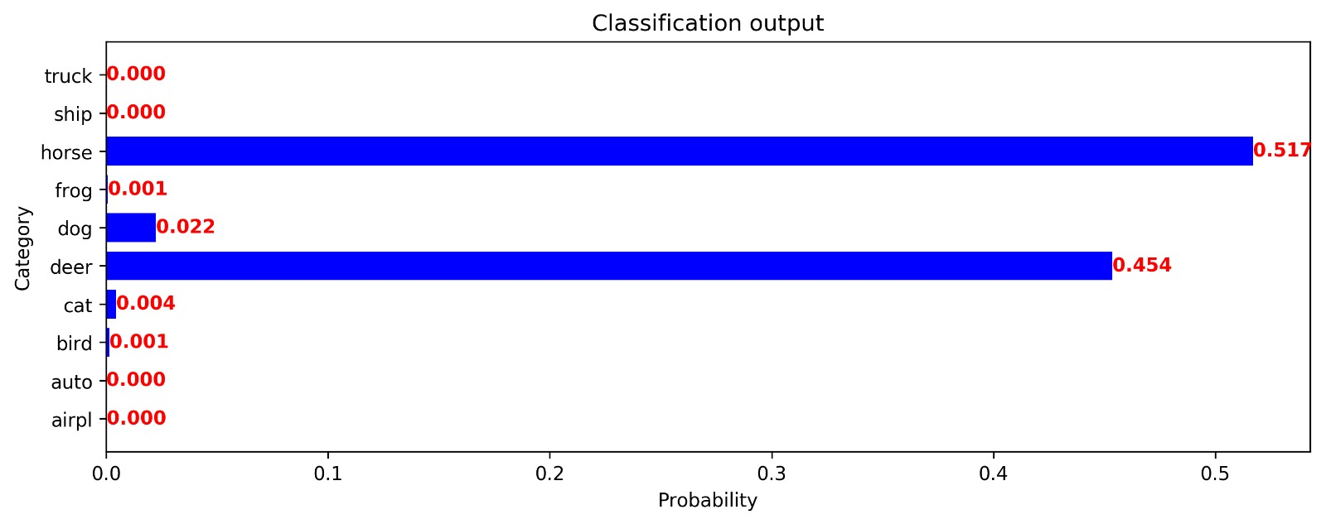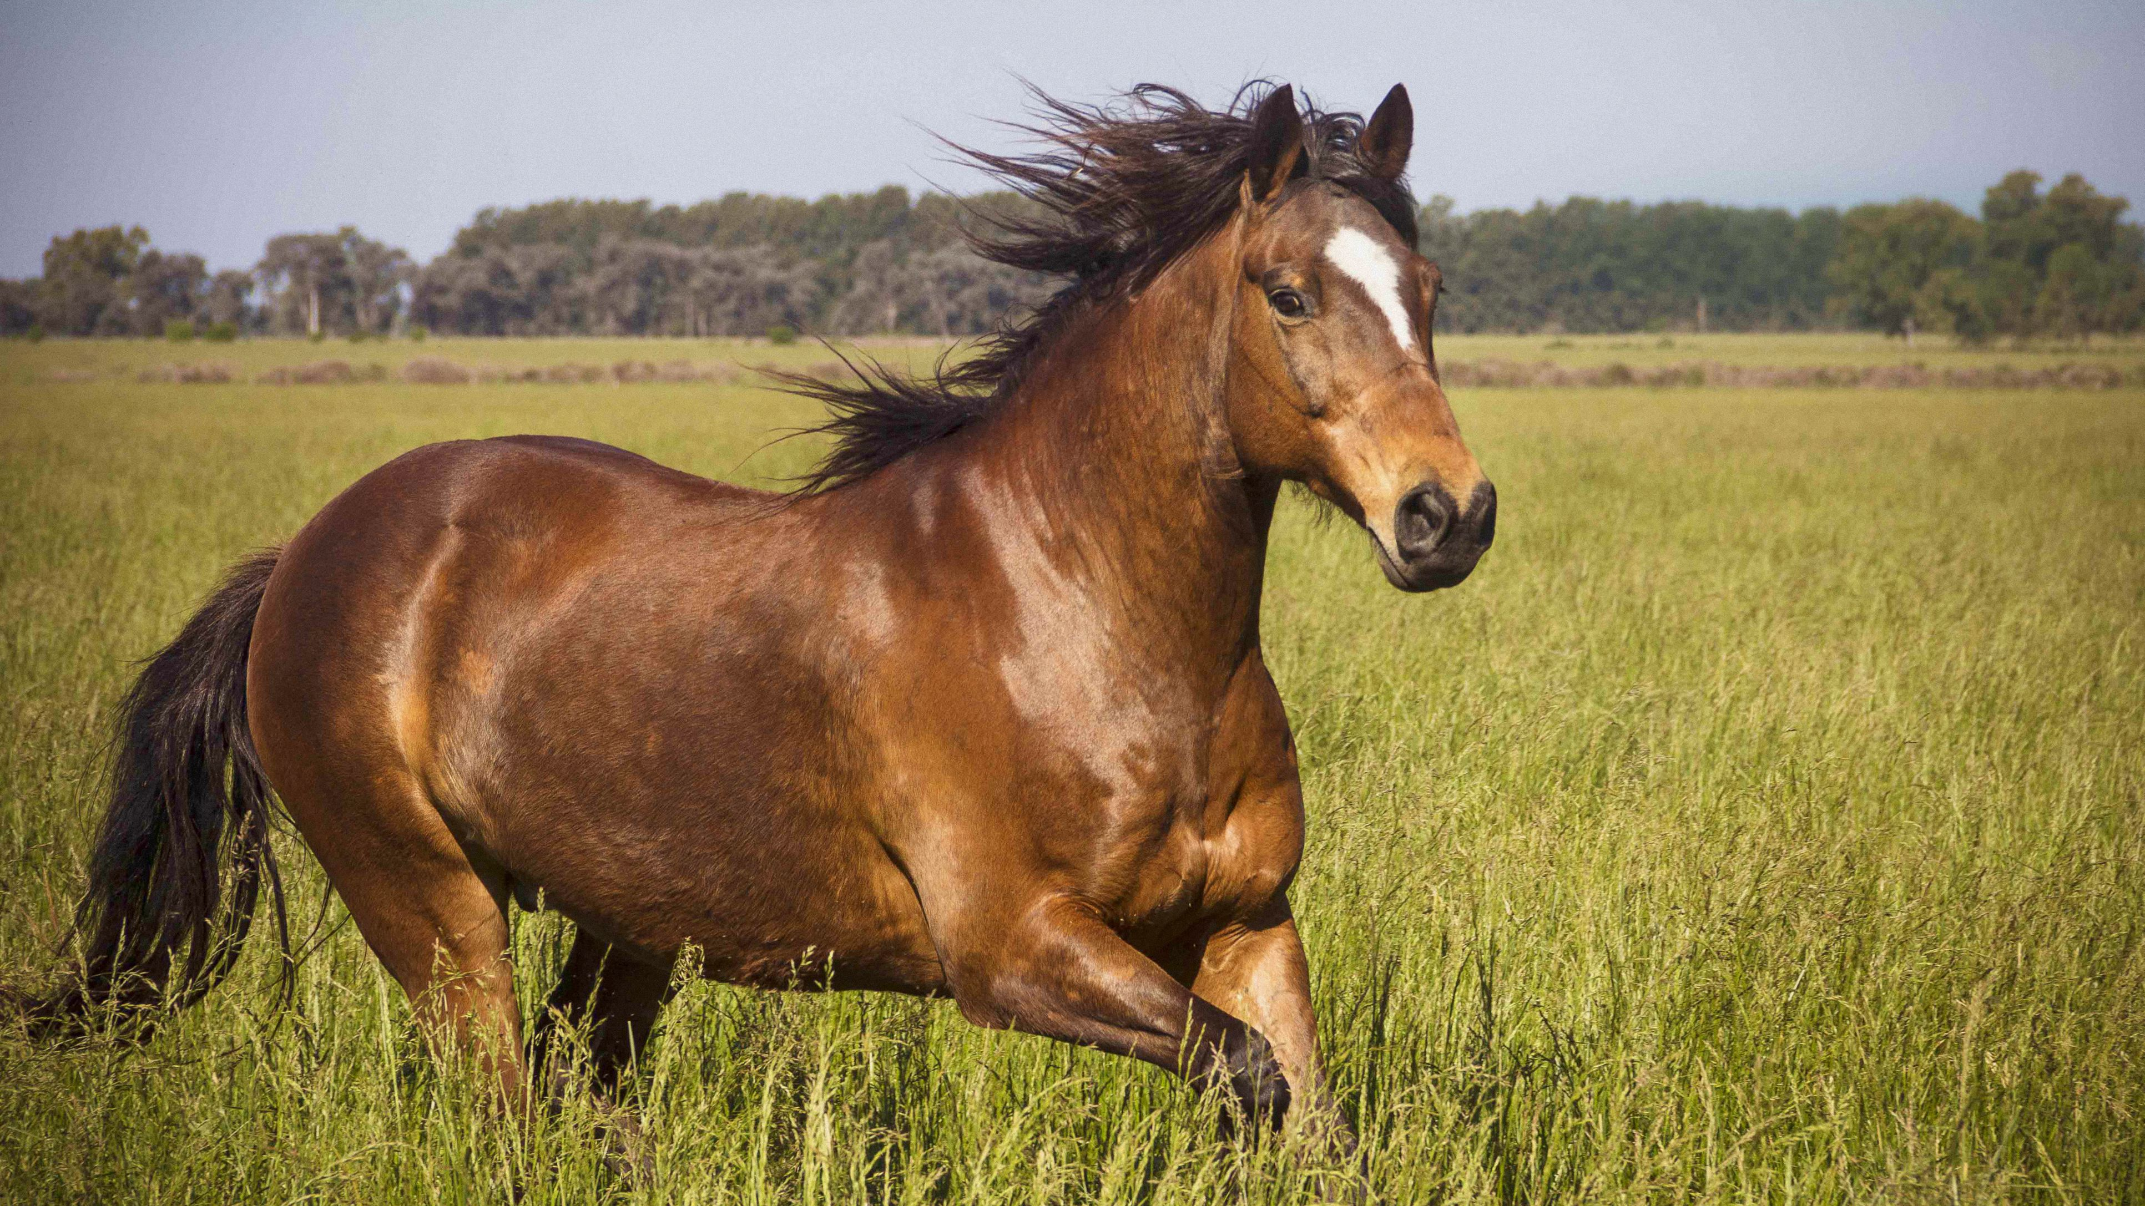

* Ship

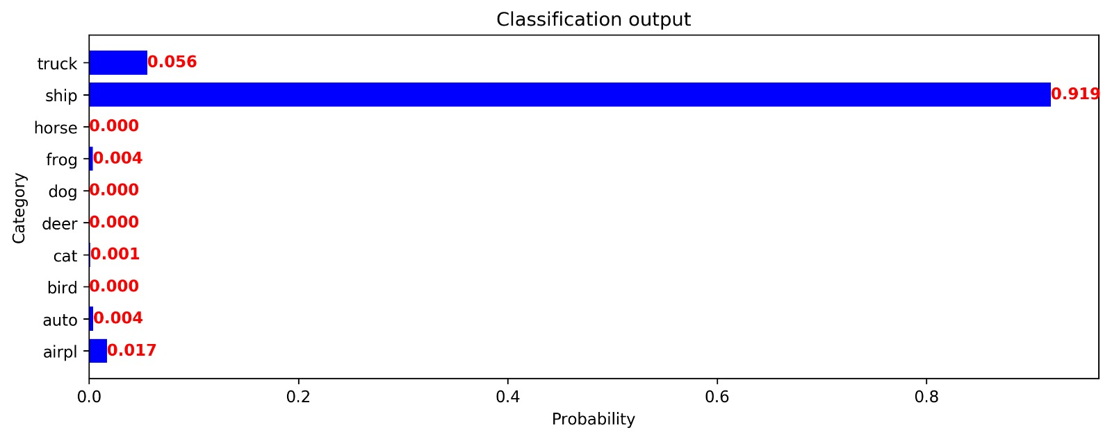

# Comparison with TSP

To compare the performance of the VGG like architecture we have trained, we are presenting here the results that we got using the TSP model. The performances that we are showing are the global network accuracy and accuracy per category.

**TSP**

**VGG**



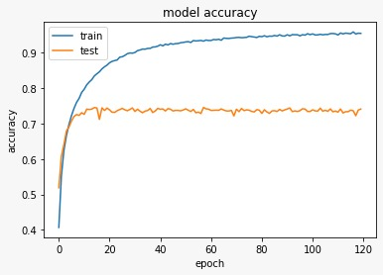

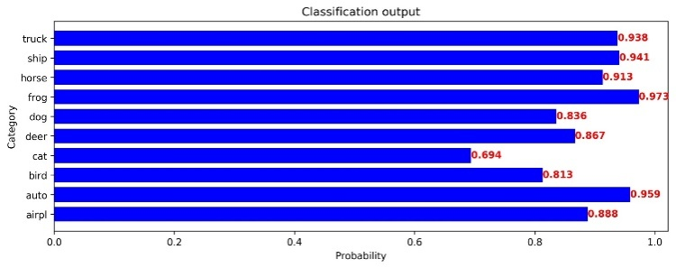

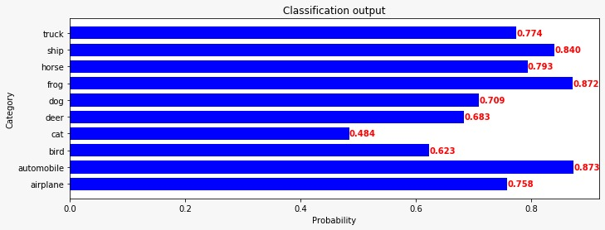

The accuracy of TSP model reaches 74% after 10 epochs and then suffer over-fitting. In the other hand, with the BatchNormalization and Drop out Layer VGG-like model able to avoid over-fitting and have a higher accuracy in both accuracy per class and overall accuracy. In term of accuracy per class, both model have a low accuracy at cat images, and higher classification performance on frog and automobile images.

# Conclusion

In conclusion, By using the presented architecture in model, we observed a serious impact on accuracy. we’re able to improve the accuraccy upto 14%.